Risk and Hazard assessment
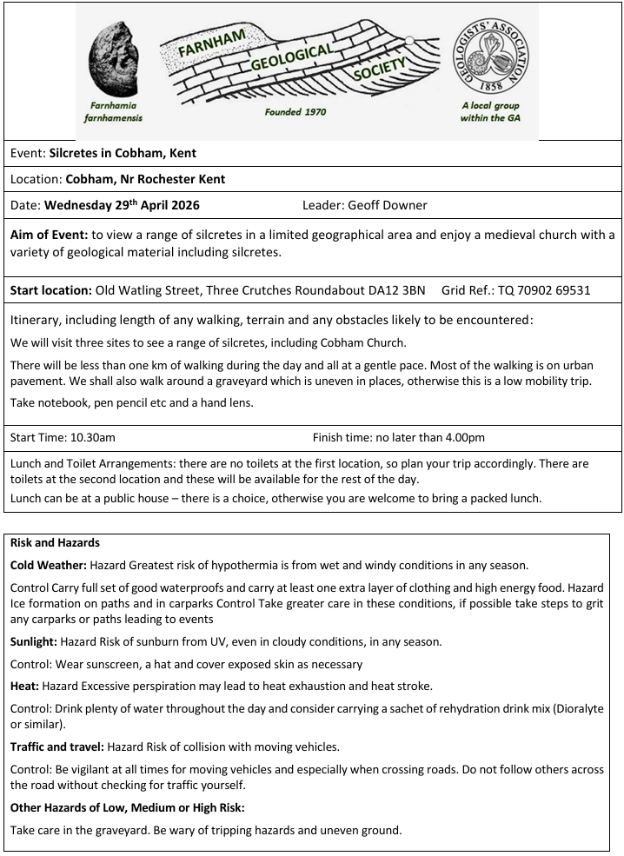
Insurance information etc.
All trips are open to members, friends and other societies. Visitors/ guests will be charged a small temporary membership fee per day to ensure coverage on FGS public liability insurance. FGS has Public Liability Insurance cover for field and indoor meetings. Each person attending a field meeting does so on the understanding that they attend at their own risk. Please be aware that FGS insurance does not cover personal accidents - Personal Accident and Personal Liability cover remain the responsibility and personal choice of the participant.
Own transport will be used on all trips unless stated otherwise - some trips will be car sharing and if you offer lifts to others, please ensure that your insurance covers you. It is the driver’s responsibility to ensure that all passengers must wear a seatbelt. (Note – it is the law that passengers must be wearing a seat belt at all times, unless holding an exemption certificate when the passenger must sit in front seat).

